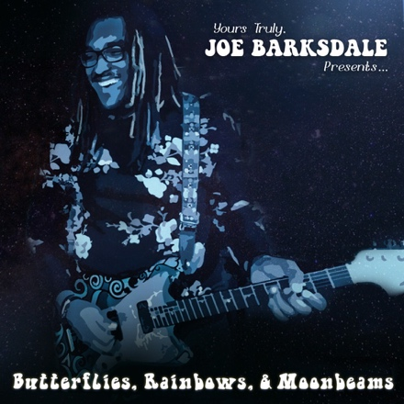
Joseph Barksdale

Bio
He’s starting his ninth year as an offensive lineman in the National Football League, but while proud of his ability on the gridiron, Joe Barksdale is less inclined to cite Pro Football Hall of Famers like Art Shell or Anthony Muñoz as inspirations as he would a star from a completely different Hall of Fame.
“I saw Jimi Hendrix and his Monterey Pop performance pretty early in my development as a musician and ever since then I wanted to play live like that,” says Joe Barksdale, offensive tackle for the Los Angeles Chargers and aspiring musician. “My goal is to be the premiere guitar player of my generation before it’s all said and done.”
He takes a step toward that lofty goal with the arrival of his first album, Butterflies, Rainbows & Moonbeams, released independently in January on his Hear My Music label.
Barksdale’s admiration for Hendrix is obvious not only in his respectful cover of the guitar god’s “The Wind Cries Mary” but his playing style throughout the album.
Butterflies, Rainbows & Moonbeams ranges from hues of blues and neo soul to contemporary jazz and alternative rock. It’s an especially confident album considering Barksdale only started learning his second job less than five years ago, a quest that began at the suggestion of his football coach.
“I experienced a pretty significant death in my life when the 2013 season ended, Charleston Fobbs, a guy who was like my Dad,” Barksdale recalls. “Jeff Fisher, who was the head coach of the Rams at the time, asked me what I was doing for the offseason, because he knew I was still hurting. He told me I should pick up the guitar because he saw a lot of similarities between his son and me. He said his son really enjoyed the guitar and he suggested I try it, too, so that’s what I did.“
He took the challenge seriously, opting for professional lessons, rather than the self-taught route. “At first I was going to try to teach myself on YouTube, but then I thought about it: I didn’t teach myself to play football watching YouTube. If I was going to pick up guitar as a hobby, than I would just been okay to take some YouTube lessons, teach myself a couple chords and be done with it.”

Seeing footage of Hendrix’s Monterey performance made guitar more than a flirtation. “I wanted to be everything that Jimi Hendrix was, as a musician and as a guitar player for sure. It’s funny, my current guitar teacher, Mark Shapiro, just swears that if Jimi Hendrix had been 6’5”, 300-plus pounds, he’d be me and vice versa.”
Although the guitar started his musical quest, Barksdale eventually became a cozy singer, too, and has added vocal lessons to his non-football schedule. “When you look at where you want to be and you look around at guys who are there, you see what they’re doing that you’re not. Everybody from Hendrix to John Mayer, Freddie King, all these guitar players I’m trying to emulate, they’re not classically trained singers or ‘take it on home every time’ singers, but they all sing effectively and with emotion. I felt like if I wanted to be taken seriously as a musician I had to be the whole package.”
While music might seem a surprising sideline for an offensive tackle, a football career seemed even more unlikely to a young Barksdale. At age 13, his passion was engineering, which led him to enroll in the Detroit Area Pre-College Engineering Program. Mischief instigated by a friend got Barksdale dismissed early from the DAPCEP; still in need of a summer activity, a football program was one of the few options that remained available.
What started as a means to keep out of trouble became a fruitful path when Barksdale’s size and ability on the football field led to scholarship offers. After an early graduation from high school, he was courted by Michigan State, Ohio State and Notre Dame, but chose Louisiana State University, in part for its engineering program.
“One of the main reasons I went to LSU was because they told me I could get an engineering degree, but when I got there, I ended up getting on the field earlier than anticipated. Engineering classes ain’t gonna’ fly during football practice so I had to switch majors to pre-law.”
Barksdale was a starter for the LSU team that won the NCAA’s football championship in 2008 and was drafted by the Oakland Raiders in 2011. After two years there, he next played for the two NFL teams that now reside in Los Angeles, joining the Rams in St. Louis in 2012, the Chargers in San Diego in 2015.
“I am extremely competitive, extremely, and I apply that to my music career. That’s why I’ve been telling everyone who interviews me that I am going to be one of the greatest guitar players of my generation before it’s all said and done.”
The scope of genres on Barksdale’s debut reflect his broad tastes, a path that began with “Gospel, rap, soul and R&B: those are the four major food groups for black, inner-city Detroit.” Attending plays and concerts with his mother during high school years opened his ears to classical, swing and jazz, while college introduced him to alternative rock and neo soul. Shortly after college, he immersed himself in the blues, a passion of his grandfather.
“I don’t think my music is definable,” says Barksdale. “You know, it hits you in the soul and it feels good.” Aside from the Hendrix song, Barksdale also covers blues greats Elmore James and Freddy King and alternative band MGMT, but the bulk of his album are originals, six by Barksdale and three co-writes, one with wife Brionna.
Barksdale eagerly shares credit with his collaborators, including long-time San Diego singer Rebecca Jade and Prince protégé Natalya Phillips. “I think some of that comes from me being an offensive lineman and never getting credit for anything,” says Barksdale. “You don’t want people to feel like linemen do at the end of the day; you want them to know they did a good job and that you appreciate them. That’s not just important to me as a musician but in life in general.”
Just as Barksdale is serious about music, his new career and has been taken seriously, earning ink in the Los Angeles Times, San Diego Tribune, outlets in his hometown Detroit and elsewhere. He scored an endorsement deal with Fender, and the instruments giant helped promote his album’s launch at the annual National Assn. of Music Merchants (NAMM) convention in Anaheim.
“I have a lot of admiration for Fender and I’m so thankful for the people there because they were the first major corporation who believed in me as an artist,” says Barksdale. “It makes you feel good when you get to NAMM and see Fender has the biggest booth in the world. It motivates you to keep working. “

